NOTE: Picture on the left is Wrong.

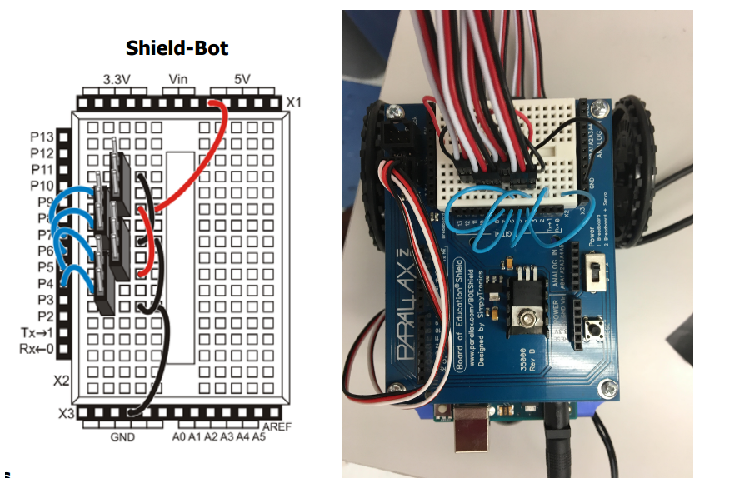

In this section I will tell you whats wrong with the connections in the picture you sent me:

1. The blue wire to the most right of the image you sent is not connected to anything. Same with the wire to the left of it.
2. The second blue wire from the left is shorted straight to ground which could damage the robot.
3. The first blue wire from the left is connected to power and is not really doing anything.
4. There's no power connection coming from 5V socket/s. so there is no way the QTIs had any power.
5. I can't really see how things are connected on the other side of the male headers.

